GIVING HOPE ADOPTION PACKETS
Below are the items needed to make Giving Hope packets and where to purchase them.
SAM”S CLUB
Member's Mark 33 Gallon Power-Guard Drawstring Trash (90 ct.) Item #: 988335 | Model #: MM33DS090B | $ 15.48
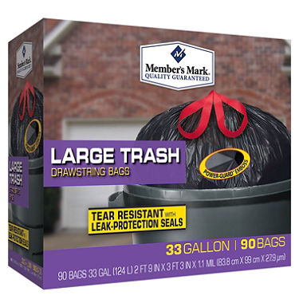
ULINE.COM
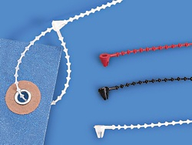
Beaded Security Ties
MODEL
NO.
LENGTH | DESCRIPTION | TENSILE  (LBS.) | QTY./  PACK | PRICE PER PACK | ADD TO  CART
 |  |  |  |  | 1 | 5 | 10+
S-8092 | 8" | Natural | 15 | 2,000 | 48 | 46 | 42 |  | ADD

Uline White Tyvek®
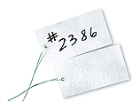  MODEL  NO. | SIZE |  | PRICE PER 1,000 |  |  |  | ADD TO  CART
 |  |  | 1 | 2 | 5 | 10+ | ADD TO  CART
S-2024 | 4 3/4 x 2 3/8" | #5 | 69 | 66 | 62 | 58 | Specify Style

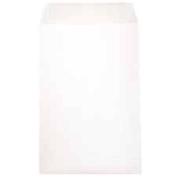
OFFICE DEPOT

- JAM Paper® Open-End Catalog Envelopes, 6" x 9", White, Pack Of 25
Item 243732 $ 3 99 $3.99 / pack

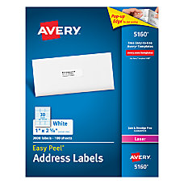
- Avery® White Laser Address Labels, 1" x 2 5/8", Box Of 3,000
Item 364364 $ 29 99 $29.99 / box

