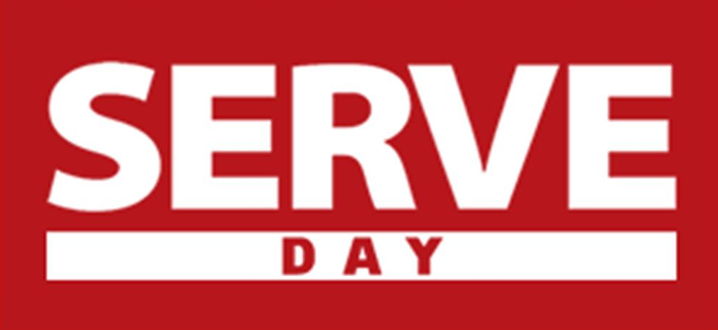

GENERAL INFORMATION
- Details about SERVE Day can be found at www.churchofthehighlands.com/serve
- Small Groups should be registering their projects online at www.churchofthehighlands.com/serve
- SERVE Banners & Booth are being manned on Sundays at every campus for SERVE Day questions and help.
- A listing of adoptable projects for individuals and small groups are on the site.
- Campus Anchor projects and contact information will be listed on the site by June 29th.
- SERVE t-shirts will be distributed at each campus on July 5th. A supply of shirts will also be available at all campus project headquarters the day of the event.
- There are adoptable yard work projects (widows & Single moms) that each campus outreach hub leader can connect any small groups looking for a project.
- Encourage everyone to tune in at 9am prayer on July 12 via live stream for a word from Pastor Chris.
- Outreach Interest cards will be in the worship guide on July 12 for individuals interested in getting involved in Outreach after Serve Day.
- Official social media tag is #SERVEDay15
- If people have a project idea they would like to submit they can do so at serve@churchofthehighlands.com .

I want to participate in SERVE Day but I am not in a small group. How do I find a small group?
Most groups are open to new members throughout the semester. Our Small Groups Directory can help you find a group that fits your interest, location and time preference. Learn more about small groups at www.churchofthehighlands.com/groups.
You can also check out the Small Group Projects beginning June 1 where you will find a list of small groups that have projects that have room for you to help them with their project. Simply find a project you like and contact the leader listed.

Will there be SERVE projects available for those NOT in a small group?
Yes, we will have one or more large SERVE projects at each of our campuses for you to participate in on SERVE day. Many of the small groups are open for you to join them on their project. These opportunities will be posted on the Small Groups and Campus Projects pages by name. Feel free to bring your family and participate.

What if I don’t have a project selected and my small group wants to SERVE?
Hopefully, you have selected something to do together, but if you are in need of an idea, you can check out our list of ideas for ways to get involved. We will also have a list of adoptable projects to serve with some of our Ministry Partners.

How do I plan a SERVE project?
Get creative! Assess people and their needs in your neighborhood and around your community. Perhaps there is a widow, single mother, or elderly person that could be assisted by painting their house, cutting grass, or cleaning up the yard. Firefighters, police officers, school resource officers, nursing home residents, assisted living homes, and local business owners are all great people to reach out to and find a way to SERVE! Check out our list of ideas and other options from local service organizations for ways to get involved.

Should I communicate to the Church which SERVE day project our group is planning?
Yes, we definitely would like know about what project your group is participating in. Beginning June 1, you can register your group’s project online. We will send a reminder to all small group leaders to register their projects throughout the Summer Semester.

Who pays the costs associated with our small group’s SERVE project (supplies, travel expenses, etc.)?
Each small group is responsible for all of the supplies and costs associated with their SERVE project. Spend time determining the scope of your project and plan work based on your group size and commitment level.

What should I bring on SERVE day?
Plan on bringing any personal items you may need, like your SERVE Day T-shirt, sunscreen, drinking water, tennis shoes, a hat, etc., along with any items pertaining to your service project such as rakes, gloves, lawnmowers, tarps, work tools, etc. For projects requiring physical labor, work clothes are a good idea. We recommend not wearing jewelry.

What if it rains?
If you have an outside project, make plans to have an inclement weather option in mind. Some suggestions are to visit a nursing home, serve at a local service organization, or clean classrooms at a local school.

